

# Lenovo TAB P11

## Type of device: Tablet

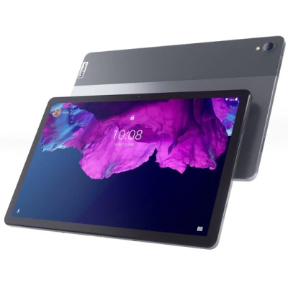

Actual Display Size : 11 inches

Operating System : Google Android

Version Number : Android 10

Year of Release : 2021

Average Price : $399 as of 22 06 2022

Internet Access : Wi-Fi Only

## Accessibility Features:

### Cognitive

* Additional Instructions
* Copy and Paste
* Flicker Free Display
* GPS
* Photo Telephone List
* Screen Timeout Disabled
* Simple Instructions
* Simple Reminders
* Simplify Display

Voice Notes

### Hearing Impairment and Deaf

* Allows for sign language communication
* Bluetooth or Wi-Fi
* Closed Captioning
* Front Facing Camera
* Video Communications - Two-way

Visual Alerts - Incoming Calls

### Vision

* Accessibility APIs supported
* Battery Alert - Audible
* Bluetooth or Wi-Fi
* Braille Display Support
* Brightness Adjustable
* Dictation / Speech-to-Text
* High Contrast Mode
* Personalised Shortcuts
* Power Cue
* Screen Magnifier
* Screen Reader
* Text Size Adjustable
* Voice Control /Personal Assistant

Voiced Menus

### Speech

* Allows for sign language communication
* Bluetooth or Wi-Fi
* Messaging Options - Email
* Messaging Options - IM

Predictive Text

### Physical

* Bluetooth or Wi-Fi
* Dictation / Speech-to-Text
* Gesture Based Navigation
* Headset - plug connected
* Predictive Text
* Reduced hand movement option
* Speaker-phone option
* Stylus or Prosthetic Device support
* Switch control option
* Visible Focus Indicators
* Voice Control / Personal Assistant
* Voice Recognition for Accessing Features

Voice Recognition for Dialling

## How and where to get it from?

You can buy this tablet from [JB Hi-Fi](https://www.jbhifi.com.au/search?query=lenovo%20p11&page=1), [Big W](https://www.bigw.com.au/search?text=lenovo+p11), [Woolworths](https://www.woolworths.com.au/shop/search/products?searchTerm=lenovo%20tab%20p11), [Dick Smith](https://www.dicksmith.com.au/da/shop/?q=lenovo+tab+p11), and other retailers.

## More information is available on:

[Lenovo TAB P11 Website](https://www.lenovo.com/au/en/tablets/android-tablets/tab-series/Lenovo-TB-J606/p/LEN103L0001?orgRef=https%253A%252F%252Fwww.google.com%252F#)

[Lenovo TAB P11 Support Website](https://pcsupport.lenovo.com/au/en/products/tablets/p-series/tab-p11?linkTrack=Homepage%3ABody_Browse%20Products&searchType=0&keyWordSearch=)